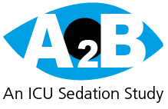

**https://www.ed.ac.uk/usher/edinburgh-clinical-trials/our-studies/ukcrc-studies/a2b**

**A2B**

Alpha 2 Agonists for Sedation to Produce Better Outcomes from Critical Illness: A randomised, parallel-group, allocation concealed, controlled, open, phase 3 pragmatic clinical and cost-effectiveness trial with internal pilot

Only 55-65% of patient time in UK ICUs is optimally sedated (defined as the absence of deep sedation, agitation & pain).

A2B aims to find out if starting clonidine or dexmedetomidine early in ICU and using them instead of just propofol can help keep patients more comfortable, decrease time to extubation and decrease problems like delirium / anxiety. We will also investigate ICU staffs’ views on how easy or difficult it is to adjust and use the drugs.

**What’s the intervention? Primary sedation randomly selected. Propofol : dexmedetomidine : clonidine**

**ICU nurse involvement? Once randomised, the primary sedation may need to be changed (administration guides will be provided). A brief form should be completed each shift to get the nurses’ perspective on managing their patient.**

**Medic involvement? Eligibility and prescribing must be done by a DELEGATED doctor. It does not take long to complete.**



**https://genomicc.org/**

**GenoMICC**

Genetics of Mortality in Critical Care

Our DNA determines how vulnerable we are to infection related critical illness. Genomicc aims to discover specific genes that control the processes that lead to life-threatening illness. If we understand these processes, we think we'll be able to design effective treatments.

To do this we need to get a single DNA sample from lots of critically-ill patients with a range of carefully-selected conditions, including COVID 19

**What’s the intervention? 1 x 9ml blood sample**

**ICU nurse involvement? You may be asked to take the sample.**

**Medic involvement? N/A**

**https://www.icnarc.org/Our-Research/Studies/Remap-Cap/About**

**REMAP CAP**

Randomised, Embedded, Multi-factorial, Adapted Platform trial for Community Acquired Pneumonia

As COVID-19 is a new disease it is not yet clear what the best treatments are. REMAP CAP investigates which treatment options are best for patients admitted to ICU with suspected / confirmed COVID-19.

It was specifically designed to be employed in a pandemic to evaluate multiple interventions simultaneously, making treatments available as soon as possible to the benefit of patients. It has already generated results that have affected UK practice, including that steroids and tocilizumab/sarilumab help, whereas therapeutic anticoagulation and hydroxychloroquine do not.

**What’s the intervention? The drug being investigated changes throughout the study, depending on effectiveness, new evidence and availability. Currently the patient may be randomly assigned any combination of simvastatin, ramipril, candesartan and vitamin C.**

**ICU nurse involvement? Once prescribed, to administer the drug (administration guides & the drugs will be provided).**

**Medic involvement? Eligibility form and prescribing must be done by a doctor.**

**ICU Recovery Research**

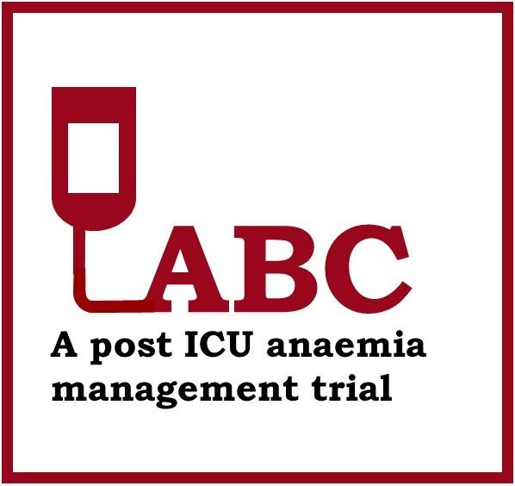

**https://www.ed.ac.uk/usher/edinburgh-clinical-trials/our-studies/all-current-studies/abc**

**ABC Trial**

Anaemia Management with Red Blood Cell Transfusion to Improve Post-Intensive Care Disability: a Randomised Controlled Trial

To determine whether correcting anaemia from the time of ICU discharge using blood transfusions results in an improvement in self-reported quality of life 3 months after ICU discharge, compared with current usual care.

**Organ Transplant Research**



https://www.nhsbt.nhs.uk/clinical-trials-unit/current-trials-and-studies/signet/

**SIGNET**

Statins for Improving Organ Outcome in Transplantation

To see if giving donors 80mg of Simvastatin prior to organ retrieval improves organ function for recipients.

**How does ICU Research Actually Work?**

1. **SCREENING** - Research nurses will screen all the patients daily to see if there is anyone eligible for research. Research has strict timelines and often has to begin soon after admission.
2. **CONSULTANT** – There will be a discussion with the consultant to ensure the study would be appropriate for the patient before anything further happens.
3. **ELIGIBILITY** – To promote both safe and meaningful research, all patients enrolled on a study must meet specific eligibility criteria. This must be assessed by a doctor (for drug trials). Some studies have limited training requirements but the eligibility forms themselves take very little time to complete.
4. **CONSENT** – Research nurses will gain consent. There are several ways to do this. If the patient has capacity, they will be provided with information and will decide for themselves. For adults with incapacity, the NOK maybe approached for consent. Before the research nurse contacts the NOK, they will discuss it with the nursing staff. In some cases, consultants can provide consent on a patient’s behalf, without contacting NOK. This is when the intervention must begin quickly or there is no NOK available. Consent will be sought from the patient as soon as they have recovered capacity. Anybody unhappy can be withdrawn immediately.
5. **RANDOMISATION** (if applicable) – computer systems randomly assign the intervention.
6. **PRESCRIBING** (if applicable) – a doctor will prescribe the randomly allocated drug. The ICU nurses will administer it.
7. **DATA COLLECTION** – Research nurses will collect data from medical notes to monitor safety and assess the efficacy of the intervention.



**WGH Critical Care Research**

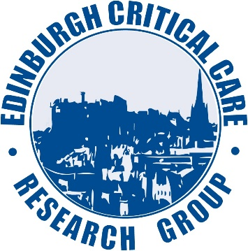



[www.ed.ac.uk/clinical-sciences/divisionpgdi/anaesthesia](http://www.ed.ac.uk/clinical-sciences/divisionpgdi/anaesthesia)

Contact Jo Singleton (Lead Research Nurse, WGH Critical Care) with any questions at all: In person / 0131 537 1958 / jo.singleton@nhslothian.scot.nhs.uk